**MASTER SLAVE ARCHITECTURE**

Jenkins uses a Master-Slave architecture to manage distributed builds. In this architecture, Master and Slave communicate through TCP/IP protocol.

**Jenkins Master:** Jenkins master acts to schedule the jobs, assign slaves, and send builds to slave to execute the jobs. It will also monitor the salve state and get back the build result responses from slave and the display build results on the console output.

**Master Slave:** A Slave is a Java executable that runs on a remote machine. Following are the characteristics of Jenkins Slaves.

1. It hears requests from the jenkins Master instance
2. Slave can run on verity of operating system.
3. You can configure a project to always run a particular slave machine or a particular type of salve machine.

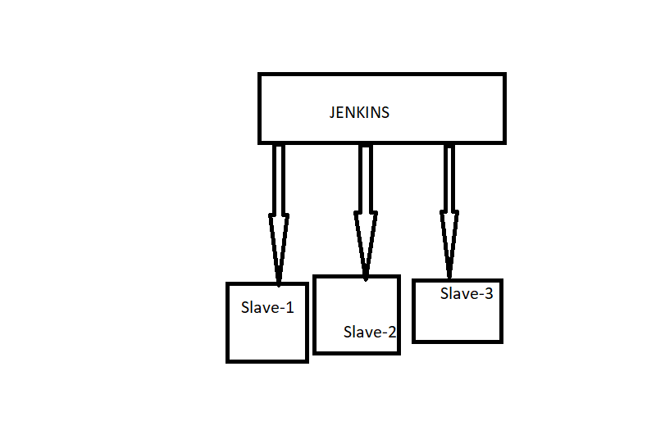

Jenkins master will distribute its workload to the slave.

Jenkins slaves are generally required to provide the desired environment. It works on the basis of requests received from jenkins master.

Are you going to install jenkins in slave?

No

Create two instance

1. Master Node
2. Slave : no need to install jenkins in slave only install java

Go to manage jenkins > select Manage node > select New node

